Dipartimento di Ingegneria e Scienza dell’Informazione

Assignment Title – Step 2

Document data: | Reference persons:
dd.mm.yyyy | Name, Familiy Name - Student ID; …

© 2017 University of Trento
Trento, Italy

KnowDive (internal) reports are for internal only use within the KnowDive Group. They describe preliminary or instrumental work which should not be disclosed outside the group. KnowDive reports cannot be mentioned or cited by documents which are not KnowDive reports. KnowDive reports are the result of the collaborative work of members of the KnowDive group. The people whose names are in this page cannot be taken to be the authors of this report, but only the people who can better provide detailed information about its contents. Official, citable material produced by the KnowDive group may take any of the official Academic forms, for instance: Master and PhD theses, DISI technical reports, papers in conferences and journals, or books.

Index

1. Assignment description 3
2. The (informal) model 3
3. Top-level ontology 3
4. Top-level grounding 3
5. Facets creation 4
6. The final ontology 4

Revision History

Revision | Date | Author | Description of Changes
0 | dd.mm.yyyy | Name | Text
… | … | … | …

Layout

- Paragraphs. Times Roman size 12 should with line spacing 1,0 be used.
- Sections. Times Roman size 14.
- Title. Times Roman size 28.
- Footnotes. Put footnotes at the bottom of the page and use 9 points text. They may be numbered or referred to by asterisks or other symbols. Footnotes should be separated from the main text by a line.
- Illustrations. Place figures, tables, and photo-graphs in the paper near where they are first discussed, rather than at the end, if possible.
- Captions. Provide a caption for every illustration; number each one sequentially in the form: “Figure 1. Caption of the Figure.” “Table 1. Caption of the Table.” Type the captions of the figures and tables below the body, using 11 point text.
- Margins and Gaps are already defined by the current doc.

Assignment description
This section contains the same text (cut and paste) of the first section of the assignment step 1 doc.

The (informal) model
This section contains the same content (cut and paste) of section 7 (EER) of the assignment step 1 doc.
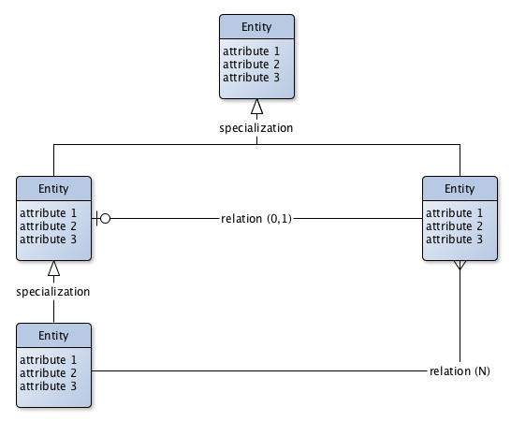
Fig. 1. An example of EER model with reference notation
This section should not be shorter than a page and no longer than 3 pages.

Top-level ontology
This section contains the description of the top level ontology (entities, relations and attributes) to be used for grounding the EER model.
This section should be at least 1 page and and no longer than 3 pages.

Top-level grounding
This section describes the mapping to the top-level ontology provided in Section 3. The top-level grounding section provides the diagram that represents the output of the mapping, i.e., an extention of the EER model of Figure 1, along with a description of some issues rised by the mapping process.

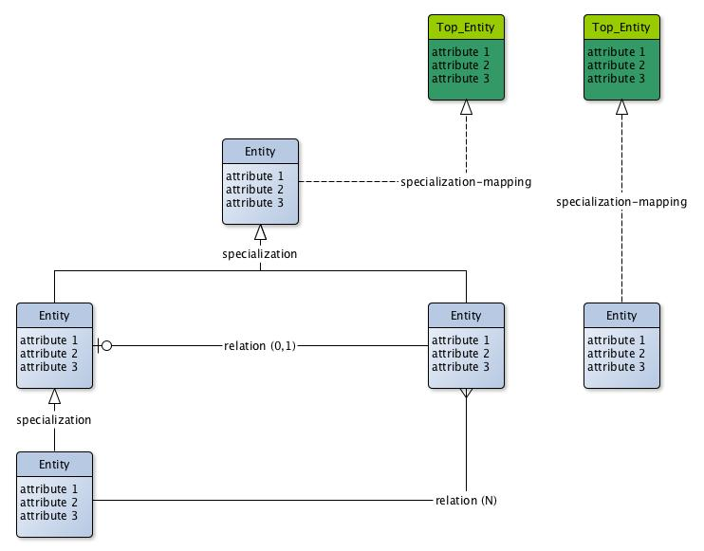
Fig. 2. EER model + top-level
This section should not be shorter than a page and no longer than 3 pages.

Facets creation
In this section the language required to describe entities (E), relations (R) and attributes (A) should be provided by applying DERA methodology (see class slides).
- Select all E from the given datasets and generate E facets
- Select all R from the given datasets and generate R facets
- Select all A from the given datasets and generate A facets
This section should not be longer than 2 pages (and not be shorter than 1 page and half).

The final ontology
This section provides the output of the formalization of the given EER model in OWL/RDF standards, i.e., the link to the Protégé file and a list of formalization issues.
- The final ontology: owl/rdf_link
- Formalization issues: 1, 2, 3, …
This section should not be shorter than a page and no longer than 2 pages.

This is how a footnote should appear.
Note the line separating the footnotes from the text.

